## Installing Microsoft SQL Server

*(****NOTE****: This section walks through the installation of Microsoft SQL Server 2019 Developer Edition and may differ slightly from other editions of SQL Server. You may skip this section if you already have an installation of SQL Server)*

Navigate to Microsoft’s webpage for downloading the Microsoft SQL Server (<https://www.microsoft.com/en-sg/sql-server/sql-server-downloads>), and download the SQL Server 2019. Run the downloaded executable.

Select ‘*Custom’* installation as not all features are needed, then click ‘*Install’* for the installer to download necessary files.

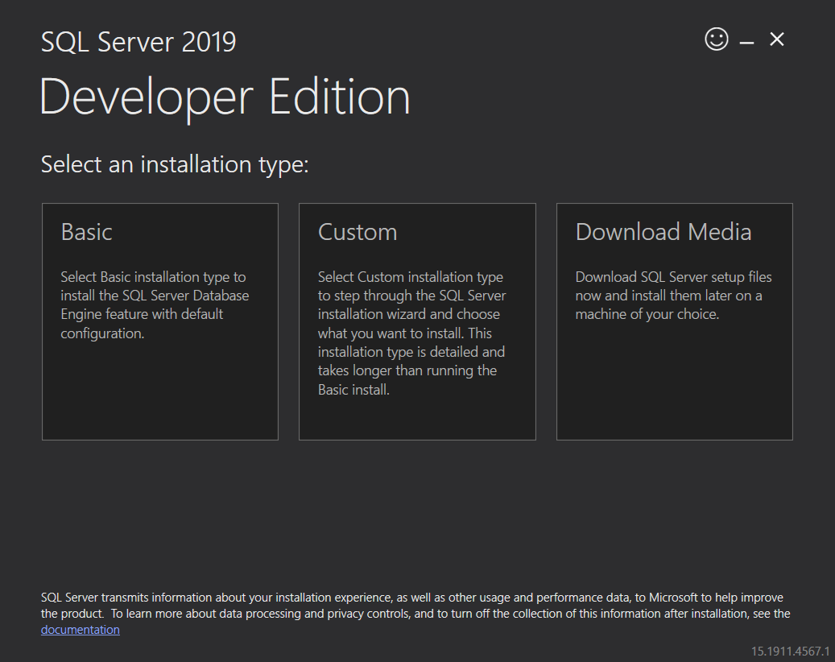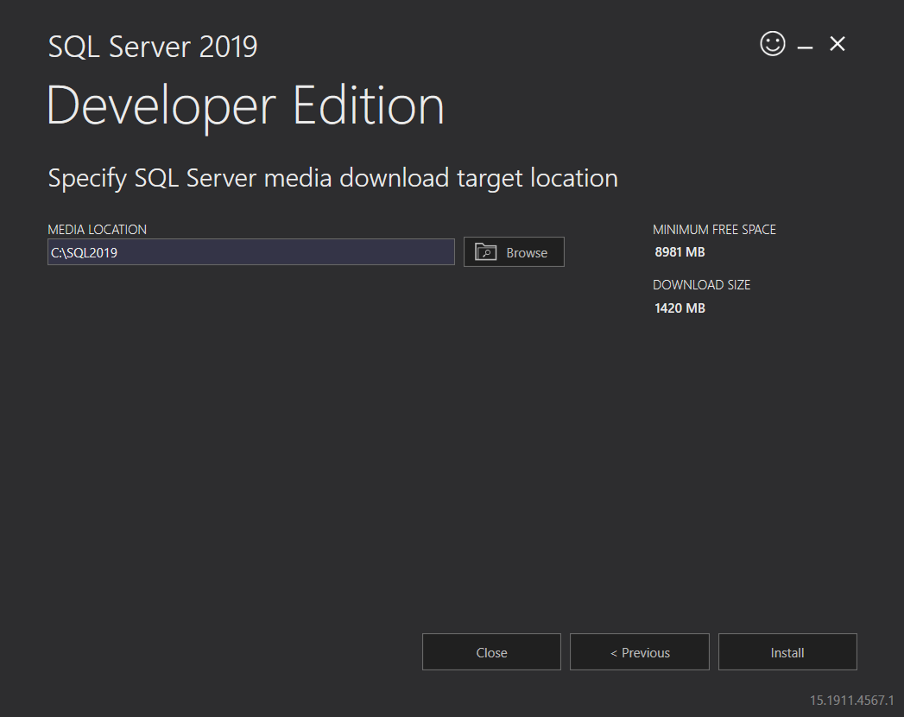

The SQL Server Installation Center will be loaded up. Click on ***Installation*** on the left navigation pane and click on ***New SQL Server stand-alone installation or add features to an existing installation***.

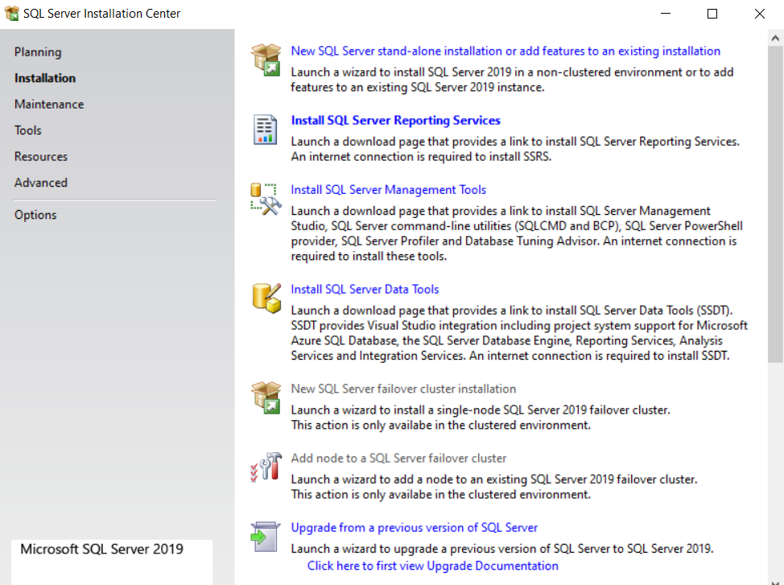

Run through the different pages of the setup by clicking ***Next***, once you reached the ***Feature Selection*** page, check the ***Database Engine Services*** checkbox and select ***Next***

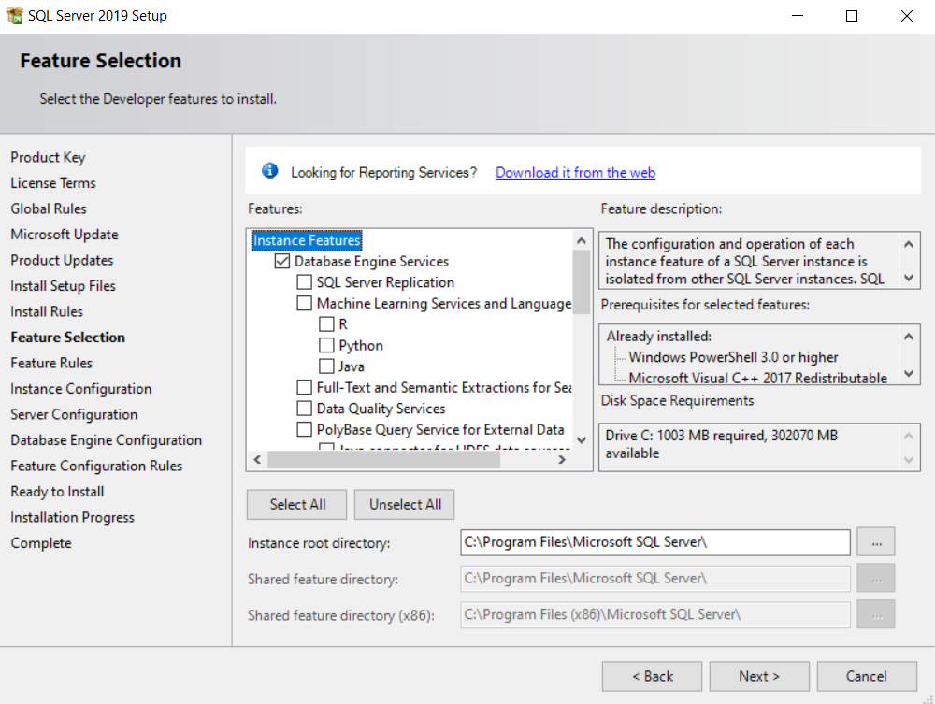

Once you reached the ***Database Engine Configuration*** page, under ***Authentication Mode*,** select ***Mixed Mode*** and type in a default administrator password. This password will be used later for connecting to the database via Grafana. Next, select ***Add Current User*** to allow for accessing to your database with your default windows authentication. This part is optional. Once you’re done click on ***Next***.

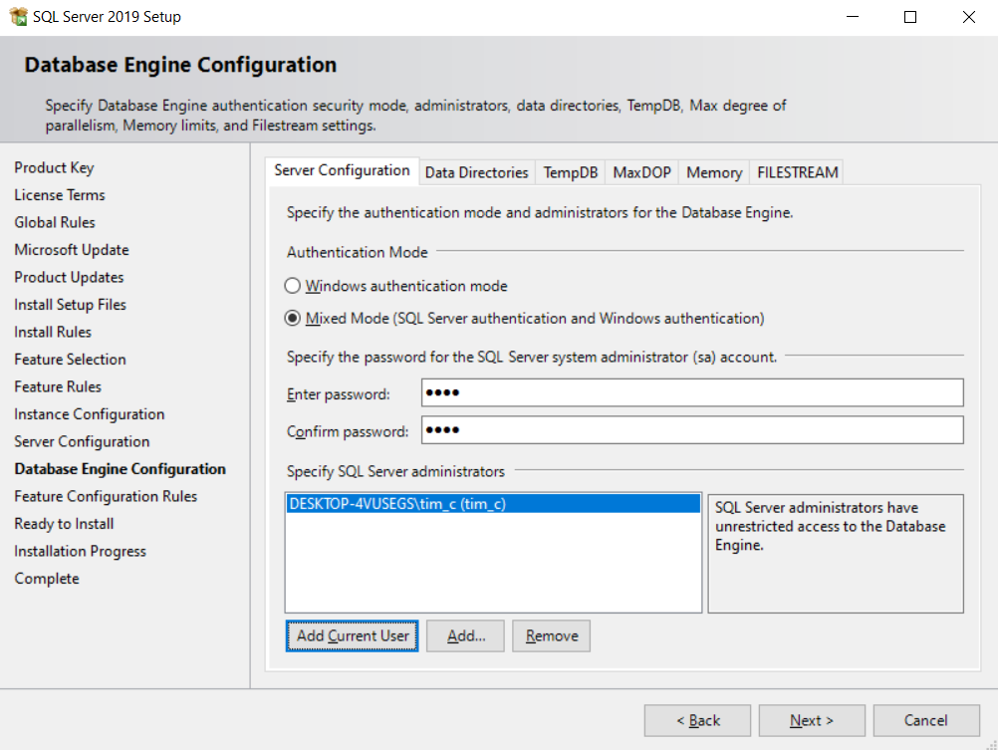

Once that is done, proceed on and allow for the installer to setup the SQL Server.

### Installing Microsoft SQL Server Management Studio

(**NOTE**:  *You may skip this if you have SQL Server Management Studio already installed)*)

The next step is to install Microsoft SQL Server Management Studio for directly accessing the data in your SQL Server database that was just installed. Head back to the ***SQL Server Installation Center*** and select ***Install SQL Server Management Tools*** from the ***Installation*** tab in the left navigation pane.

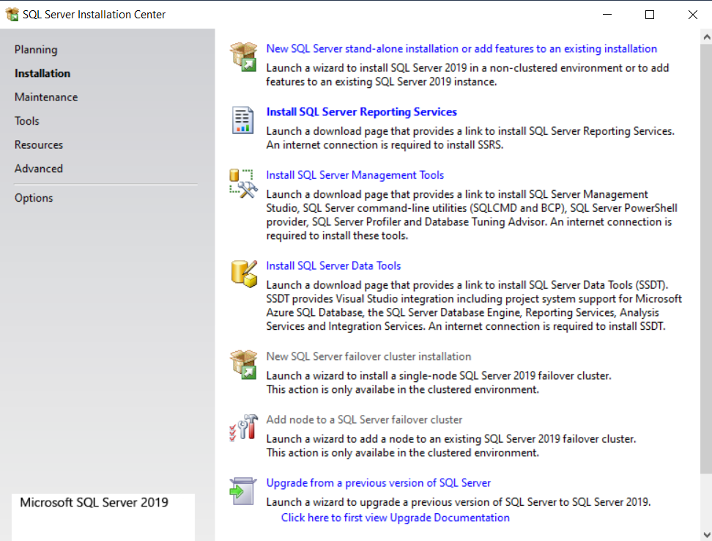

A web page should open, download and proceed with the installation.

## Import SQL Queries for Database(s)

Open SQL Server Management Studio and connect to your SQL Server instance.

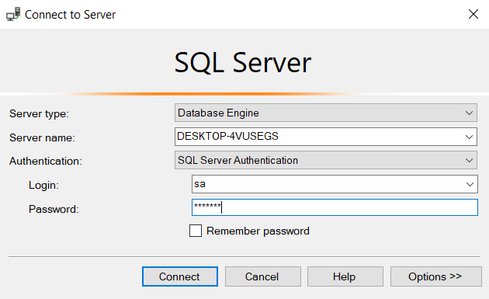

Create your new database(s) – and named accordingly. For instance, if naming database as “capstoneDB”. The field nameofdatabase in the DBscript.sql(line 1) has to be manually changed to “capstoneDB”

As mentioned, changes to configurations will have to be made to the SQL scripts for creation of tables and columns (detailed in the next step).

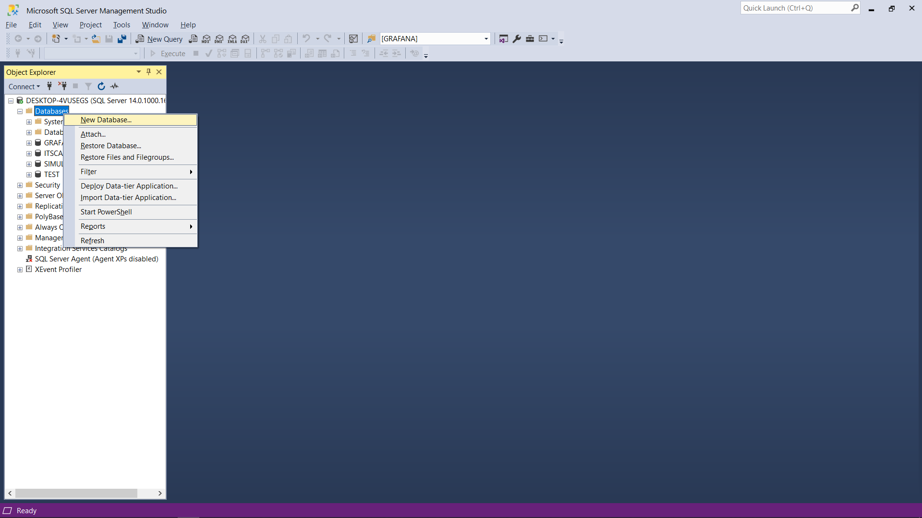

Run the script (DBscript.sql) to create the tables and columns needed for each data source. If you have previously used different database names, open the corresponding sql files of the database you used a different name of and change any instance of ‘*GRAFANA*’ or ‘*SIMULATION*’ or ‘*ITSCADA*’ (depending on the SQL file opened) in the SQL script to the different name used before running.

Next open the ***SQL Server Configuration Manager*** (this is installed together with your SQL instance), and set your SQL Server instance’s ***Shared Instance***, ***Named Pipes*** and ***TCP/IP*** to Enabled.

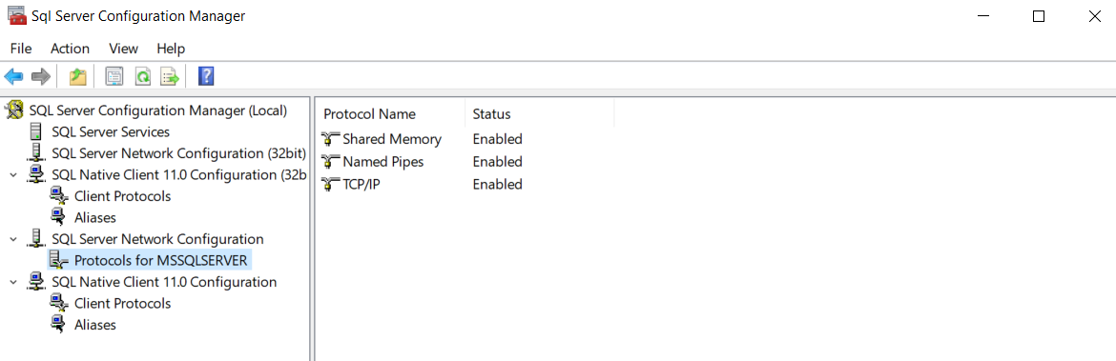

After that, restart your SQL Server instance by clicking on ***SQL Server Services***, the right-click on ***SQL Server (<your instance name>)***, and click on restart.

